Hi

For the mentioned Quote, the Contracted and Projected field values are not same. So, the contracted and projected revenue will not be same.
Below screenshot is for Date ‘05/06/2017’
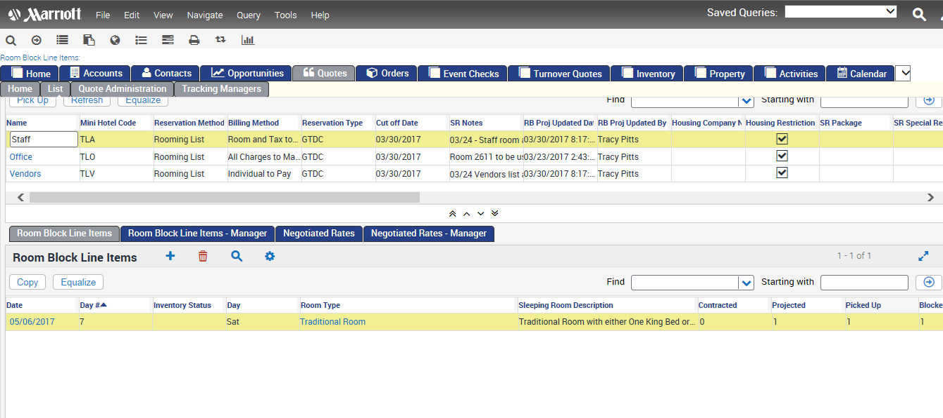
Below screenshot is for Date ‘05/05/2017’

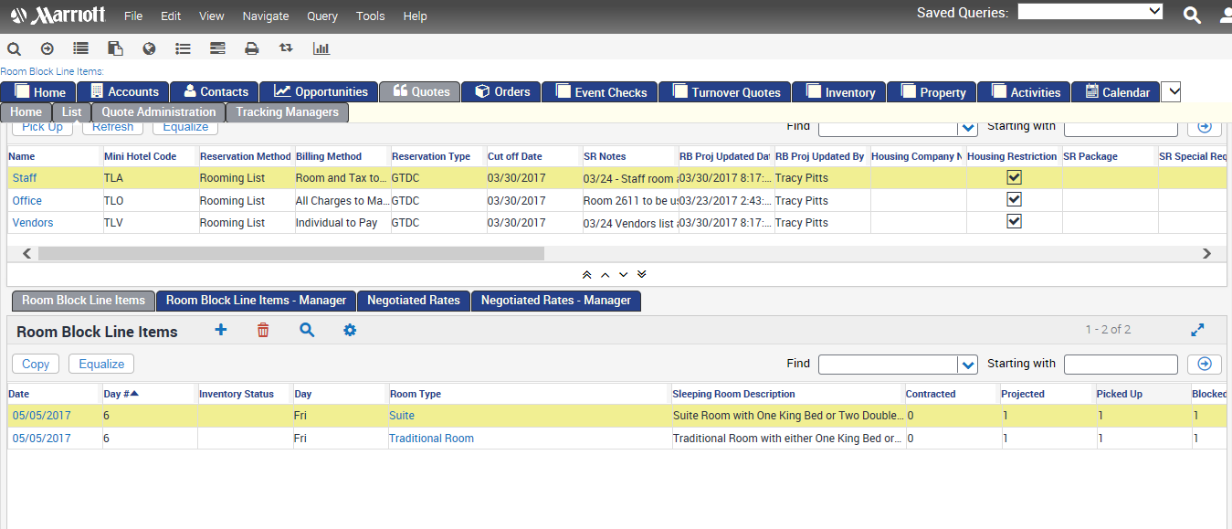

Thanks,
Sowmya

